[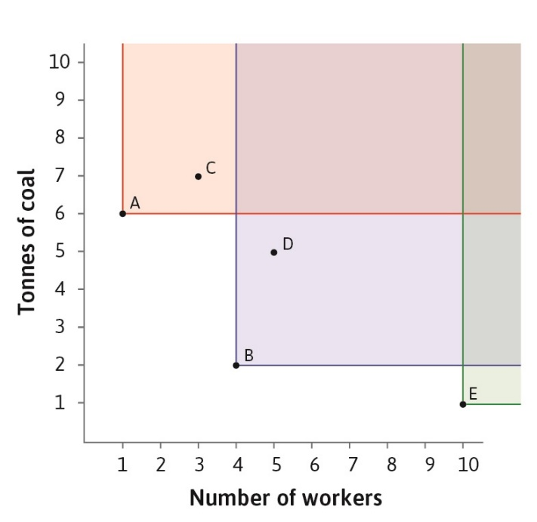](https://core-econ.org/the-economy/book/text/02.html#figure-2-4a)

Figure . 5 technologies to produce 100 meters of cloth

1. Looking at Figure 1, a profit maximizing capitalists would never choose technology A, B, or E.
   1. True or False
   2. Why?
   3. What assumptions did you make?

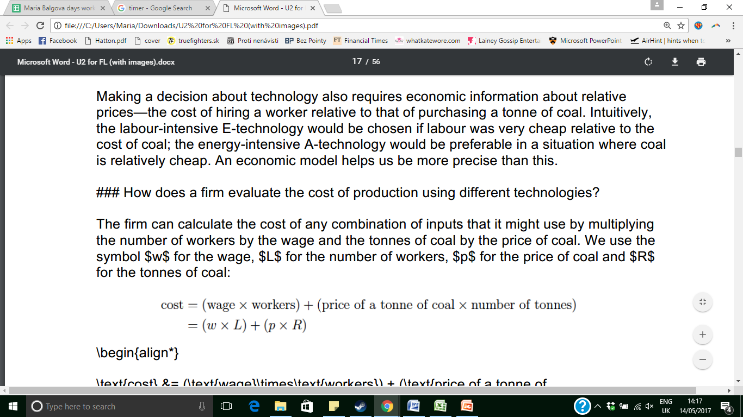

Figure . the cost equation

1. Solve the equation in Figure 2 so that it resembles $Y=a+b∙X where Y=R \& X=L$
2. Continuing with cost equation, suppose w=10 and p=20.
   1. What is the relative price of labor?
   2. Derive the isocost line for the given prices when the cost = 60.
   3. Derive the equations for the isocost lines when the cost=30 and cost=90.
   4. Plot the three isocost lines on the graph below.
3. Repeat exercise 3 but let w=10 and p=5.
   1. How do the isocost lines compare when p changed?
   2. Why is the isocost line downward sloping? How do you interpret the negative slope?

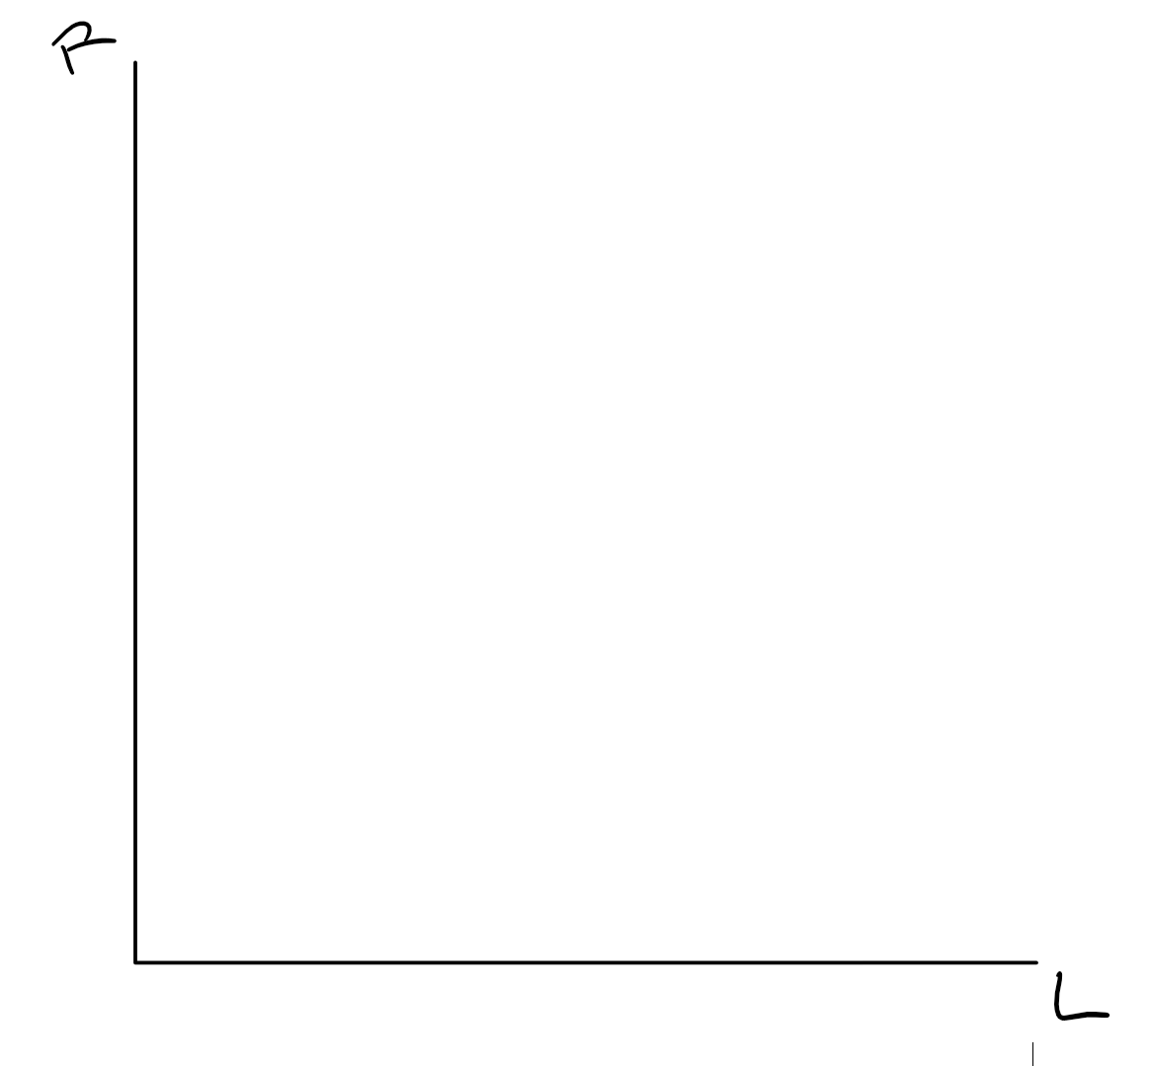

1. Consider the growth of real wages as a measure of economic progress. How does it compare with growth of GDP per capita as a measure of economic progress?
2. Is private property necessary for technological progress to occur? Why?
3. How do markets encourage innovation? (Hint: think about this in terms of rewards and punishments)
4. How can production in firms, as opposed to within familial units, contribute to the growth of living standards?