# Red/Green Game

1. What is the dominant strategy in this game?
   1. Would pursuit of self interest by all players yield the socially optimal outcome?
2. How did incentives affect your choices in the Red/Green game? And what were the consequences of your choices?

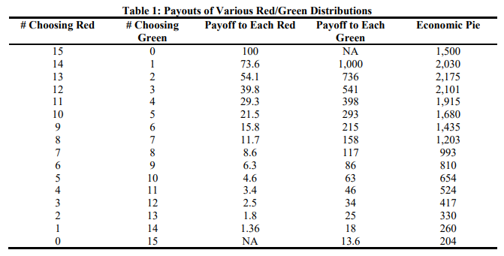

Figure 1 Payouts from Red/Green Game

By how much did the sum of the payouts to the other 14 students (10 red + 4 green) change?

1. Consider the situation when the class moves from four to five greens (one student switches from what would have been the 11th red to being the 5th green). Let’s call the student who switched Donnie.
   1. Before Donnie switched, there were 11 red students. The payout to each red (10 red students + Donnie) was ______ and the payout to each green (4 green students) was _________.
   2. After Donnie switches, the payout to each of the remaining 10 red students is _________ and the payout to Donnie and each of the 4 green students is _____________.
   3. Does Donnie receive more or less as a result of switching from being the 11th red to being the fifth green? How much?
   4. By how much did the sum of the payouts to the other 14 students (10 red + 4 green) change?
   5. Who gained and who lost because of Donnie’s decision to switch from red to green?
2. Consider what happens when Mary, Donnie’s classmate, switches from what would have been the fifth green to being the 11th red.
   1. How did Mary’s payout change relative to the change in the total payout received by all of her classmates?
   2. What happened to social welfare (the size of the economic pie) when Mary switched?
   3. Who captured the benefit and who bore the cost of Mary’s decision?
3. Use your responses from the previous two questions to discuss the difference between a cost and a benefit. Include in your discussion the differences between private (to the individual) costs and benefits and social costs and benefits.
4. Why would Mary pursue the course of action she did? (Make sure to include the concept of preferences in your discussion.)
5. How many students should choose green to yield the greatest total payout (the largest economic pie) to the class?
6. If only a few students should choose green, who are they to be?
7. Should maximizing the total payout to the class be the goal? Why?
8. Consider the following questions related to social dilemmas and describe a social interaction that contributes to the dilemma. Essentially, what you are doing is adding context to the red/green game by rewriting the rules. Specifically consider: Who is involved in the interaction? What are the actions each player can take (feasible strategies)? What information does each player know when choosing their action? What are the outcomes for all possible combinations of actions?
   1. Why do we deplete resources? (resources are an example of a common good: non-excludable = available for everyone to access, but rivalrous = one person’s use prevents another from doing so)
   2. Why do we cause climate change?
   3. Why must the government provide public goods? (non-excludable and non-rivalrous)
   4. Why are there special interests in politics? (I am referring to the lobbying of policymakers.)
   5. Why are civil liberties suppressed? (examples may include right to fair treatment under the law and due process, right to vote, freedom of speech and assembly, etc…)
   6. Why might team members not contribute to the group assignment? (you know who you are)